99DOTS Envelopes Printing Facility Assessment
Version history
18 June 2019 | Version 1.0 | Kristian van Kalmthout (KNCV)
This document can be used to assess suitable in-country printing facilities for 99DOTS. 99DOTS is a digital adherence technology that uses custom cardstock sleeves (or envelopes) to repack existing Fixed-Dose Combination (FDC) antibiotic medication blister packs. After repacking, these cardstock sleeves provide a series of unpredictable hidden toll-free phone numbers or SMS codes that are revealed each time a patient removes their pills for the day.

Product specifications
The envelope is initially a single large sheet with one side that folds over. Two remaining edges have flaps which are folded over and sealed at the manufacturer level. The last side is open and is fixed with a double-sided tape.

Outside
One side of the envelope has 28 openings for the elevated pill compartments present in the blister pack and the other side has flaps with perforations to allow pills to be dispensed. Flaps are pre-cut along the two long edges, folded at one of the short edges, and perforated along the last short edge.

Inner side
On the inner side of the flaps, phone numbers or SMS codes are printed on 14 of the 28 flaps (2nd and 4th flap in 1st column, 1st and 3rd flap in 2nd column, 2nd and 4th flap in 3rd column, 1st and 3rd flap in 4th column, 2nd and 4th flap in 5th column, 1st and 3rd flap in 6th column, 2nd and 4th flap in 7th column).

Each envelope has 14 places for phone numbers. There will be 50 skews, each with different number sequences. On each envelope skew, the numbers should be printed as per provided number sequence. Each skew can be printed separately and then the 50 skews shuffled.

Example designs and measurements
Suggested dimensions are listed below, the designs should be iterated to fit the in-country medication..

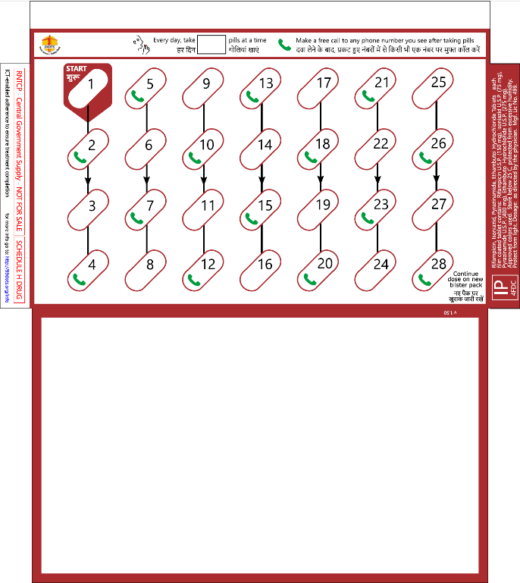
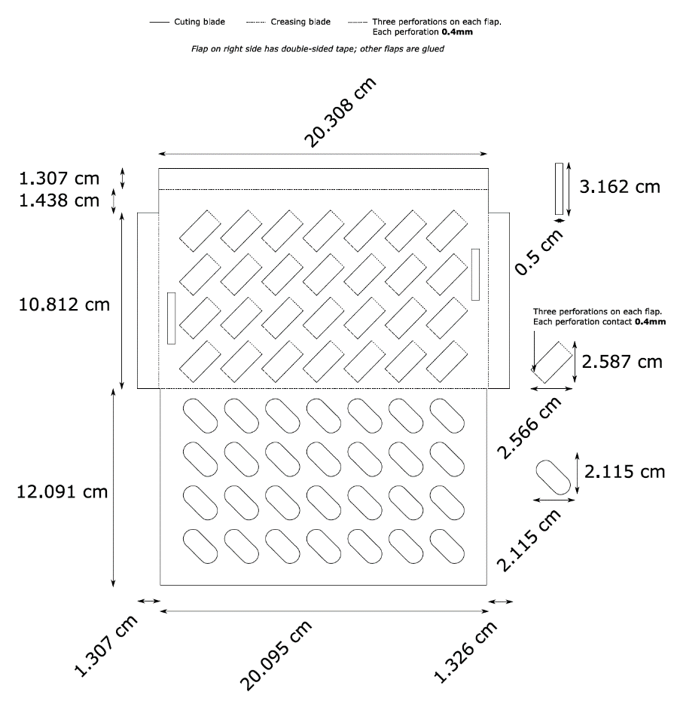

99DOTS Envelopes Printing Facility Checklist
Manufacturer information

Name of vendor/manufacturer | Example:  A+ Printing Ltd.
Contact person name, telephone, email | Megan Markle  +1 555 657 6609
Location | 1 King’s Road, Dar es Salaam
Printer specifications

What type of printer(s) is/are available? | Digital offset  Lithographic offset
What type of paper can be used? | Recommended 280 gsm aqueous coated paper
Is die cut machine to cut the specific design of the envelopes available? | Available
Is a folder-gluer machine (or by hand) to fold the envelopes and glue together available? | Not available
Is a double sided tape applicator (or by hand) to attach to the final flap which will be sealed around the medication blister pack available? | Available

