Guidelines for 99DOTS Telecom Set-Up and Telecom Assessment

99DOTS telecom set-up options:

1. Toll-free numbers
The ideal set-up for 99DOTS is toll-free numbers (TFNs), where patients call one out of a series of TFNs, hears a brief message, following which the call disconnects automatically. This provides the optimal user experience for patients: patients ideally do not require balance to make the call (though this may vary by country), multiple calls per number can be handled at once which decreases the chance that a patient’s call will not go through, and the method of calling a 99DOTS TFN should be familiar to patients in many contexts (similar to sending a “missed call”).

The technical set-up for the TFNs typically requires a PRI line (physical cable connection) from a telecom provider, which has 20-30 channels, each of which can handle one call at a time. (This may also be referred to as an E1 line, which is a type of PRI line.) The telecom provider maps our 20 virtual toll-free numbers (i.e. the numbers that a caller would call) to this PRI line. The telecom provider would also set up the TFN mapping to enable calls from each TFN to “hunt” across all PRI channels: in other words, if two calls simultaneously come to the same number, the second call can “hunt” for another available channel to connect the call. The PRI line would connect to a modem installed with PBX software, which receives the calls from all of the mapped numbers. Finally, the call event is forwarded to Everwell’s 99DOTS server, which records the call. (In case we are working with a telecom aggregator/service provider, the call may be forwarded first to their server, and then forwarded to Everwell’s server.)
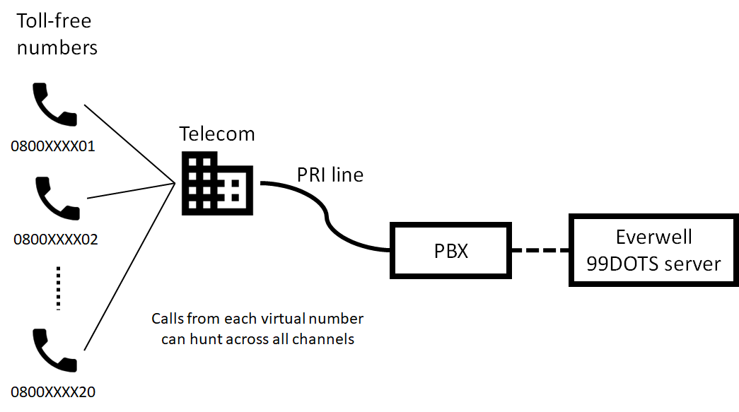
A telecom aggregator may already have PRI lines set up with a particular telecom network, which greatly eases the set-up required on our end. If working directly with a telecom network (e.g. Airtel, MTN), they may be able to host the set-up on their premises, which would also make set-up and maintenance easier for us. In case we would need to set up our own PRI connection and PBX, then we would need to ensure that the place we host it has a constant power connection (in case of power outages, would require UPS back-up for maintaining power throughout).

Technical requirements for 99DOTS TFNs
- Rental of 20 toll-free numbers with an E1 line (or comparable set-up), ideally with shared prefixes (only last 2 digits varying), call hunting across all channels for all numbers
- 2-3 second pre-recorded message to play upon calling
- Calls to be charged per second (because of our high number of < 1 minute calls)
- Forward the call event to Everwell’s HTTP API with caller ID, number dialed, and call timestamp
- Expected volume of ### calls per day (depending on expected # of patients enrolled simultaneously)
- Accessible from every network operator and region in the country
- High reliability: Due to patients’ high-frequency calling of the TFNs, we would quickly notice whether calling is not reliable. 97% reliability means that, on average, one call per month for a patient calling daily would not go through.

2. Toll-free SMS or USSD
In contexts where TFNs that work for all telecom networks and regions across the country are not available, and where patients are familiar with SMS or USSD interfaces, we may consider using toll-free SMS or USSD instead. In this case, a patient would send a short message (e.g. a three-digit number “135”) via SMS/USSD to a fixed shortcode each day.

It is okay if one telecom network is not able to provide a shortcode that would work on a toll-free basis for patients from all networks. In this case, you should procure a shortcode from each major telecom network, which patients using that network can send messages to.

Technical requirements for 99DOTS SMS or USSD:
- Rental of toll-free SMS/USSD shortcode(s) that would cover users of all telecom networks
- Send back pre-set message upon receiving patient’s message
- Forward the SMS/USSD event to HTTP API with caller ID, message sent, and call timestamp
- Expected volume of ### messages per day (depending on expected # of patients enrolled simultaneously)
- Accessible from every network operator and region in the country
- High reliability: Due to patients’ high-frequency messaging, we would quickly notice whether the service is not reliable. 97% reliability means that, on average, one message per month for a patient calling daily would not go through.

3. 99DOTS Portable
In contexts where toll-free numbers, SMS, or USSD is not available or prohibitively costly to set up, we may consider using the 99DOTS Portable solution, which uses regular SIM cards installed in specially configured Android phones. Patients would call one of the regular numbers each day, and the call would be cut automatically without picking up the call, after which patients would receive an SMS confirming that their call was received by the 99DOTS system.

The main downsides to using 99DOTS Portable instead of TFNs are:
- Patients may need to have a minimum airtime balance to place an outgoing call to a regular number (even without the call connecting).
- In case of two patients calling the same number simultaneously, the 99DOTS Portable regular numbers can only handle one call at once, while the other would not reach the 99DOTS system. Because of this, patients should ensure that they receive the confirmation SMS, and call again if not. The likelihood of this is low with a small number of patients and with a sufficient number of 99DOTS Portable phones, but makes this solution not ideal for large-scale projects.

Assessing 99DOTS telecom solutions and providers

Choosing a 99DOTS telecom solution:
- Are TFN services available nationwide? (one number can be used on toll-free basis for callers from all networks, in all regions)
IF NO:
  - Are SMS/USSD services commonly used?
  - Are toll-free SMS/USSD services available nationwide? (does not have to be the same shortcode for all networks, but service should be available for each network)
IF NO: Consider using 99DOTS Portable.

Assess feasibility, set-up time, and cost for different available toll-free solutions:
- Is it possible to get 20 TFNs set up within project timelines?
- What is the one-time set-up cost for 20 TFNs? What is the monthly rental cost? Are there fees per telecom network?
- What is the set-up cost of toll-free SMS/USSD? What is the monthly rental cost? Are there fees per telecom network?
IF NONE ARE FEASIBLE, TIMELY, OR WITHIN BUDGET: Consider using 99DOTS Portable.

Assessing telecom providers for TFNs:
- Is the provider a telecom network operator (e.g. Airtel, MTN, etc.) or a telecom aggregator (e.g. Africa’s Talking)?
In general, we would prefer an aggregator if they already have a pre-existing TFN set-up. This makes set-up considerably easier. Aggregators would also often have existing relationships with telecom networks, which could give them better leverage in negotiations, raising issues, and other communications with the networks than we would on our own. However, in cases where aggregators are not available, or where they do not have TFNs set up already (i.e. they don’t already have have a PRI line or similar with TFNs with a telecom network), it may be better to work directly with a telecom network.
- Do they understand and appreciate our technical requirements?
When approaching a telecom provider, it is important to stress the uniqueness of the 99DOTS system and hence its specific and unusual technical requirements: most uses of toll-free lines would be for customer service or other such help lines, which often do not have such rigorous requirements.
- Do callers need to have some minimum amount of airtime to call the TFNs?
- Is it possible to get 20 TFNs?
If there are regulations or other hesitations (government- or telecom-imposed) around providing a large number of TFNs to a single client:
  - What would be required to get approval?
This could include a formal letter from Everwell/implementing organizations, a letter from the government (if the NTP is involved or approves of the project), an in-person meeting with a manager at the telecom network, etc.
  - How long would it take to get approval?
What risks are there? Would this likely happen within project timelines?
- Once approved, would the provider already have a ready-to-go TFN set-up which we could use?
If not:
  - Would the provider be able to host the TFN set-up, or would we need to do the set-up ourselves (get a PRI line, buy a PBX, etc.)?
Note that this could be quite costly to set up.
If we would need to set up the TFNs ourselves:
    - Do we have a place to set up the PRI line and PBX with a constant power connection (UPS back-up in case of power outages)?
- For the given required set-up: Once approved, how long would it take to set up the TFNs?
What risks are there? Would this likely happen within project timelines?
- What are the set-up and maintenance costs?
What is the one-time set-up cost for 20 TFNs? What is the monthly rental cost? Are there separate set-up or maintenance fees per telecom network?
- What is the reliability of the service like? Is there a guaranteed minimum uptime (as per an SLA)?
The 99DOTS system requires a very high level of reliability: Due to patients’ high-frequency messaging, we would quickly notice whether the service is not reliable. 97% reliability means that, on average, one message per month for a patient calling daily would not go through.
- What is the process for raising issues? Is there a guaranteed response time?
- Are they able to offer per-second (instead of per-minute) billing for the TFN calls?
Because 99DOTS calls are very short (but high volume), it is beneficial for us to be billed per-second.
- (assessment by Everwell/implementing partners) How responsive is the provider to queries?

